**TECH HACK**

**Team 7**

**Team Members:**

1. **Dhruv Athaide (Group Leader)**
2. **Shivam Badhopulu**
3. **Sambhav Choudhary**

**Domain: Smart Education**

**GitHub Project Link:** https://github.com/Sammmy22/tech-hack-project

1. **User Story Document:**

In our User Story Document, we have created a Google Sheet File which lies in the Google Drive of the Team 7 Group. We have connected a feedback form which automatically sends the form data to our Google Form and we can directly access the Feedback from the Google Drive. I have provided a screenshot of our Google Sheet Document for the User Story Document and below it I have provided a Screenshot of our Feedback Form which will be implemented on our Smart Educational Website.

|  |  |  |  |  |  |
| --- | --- | --- | --- | --- | --- |
| **EPIC** | **AS A USER** | **I WANT TO** | **SO THAT I CAN** | **USER STORIES** | **FEEDBACK FROM USER** |
| AI powered tracker for enhanced learning experience | student | wants to learn a new subject | I want to be able to use an AI-powered learning system that uses machine learning algorithms to personalize my learning experience based on my strengths and weaknesses | I want the system to track my progress and provide me with recommendations on what topics I need to work on. This will help me to focus on the areas where I need improvement and accelerate my learning. |  |
| Inclusion of badges and XP ie experience points | student | gamified learning experience | I can earn points, badges, and rewards for completing lessons and assessments. | I want the gamification aspect to be designed in a way that is engaging and motivating, so that I am incentivized to continue learning and improving. |  |
| A translator or realtime mentor to help students | student | I want to have access to a chatbot | that can provide me with support in multiple languages. | . I want the chatbot to be able to answer my questions, provide feedback, and offer personalized recommendations based on my learning needs. This will help me to overcome language barriers and access the educational content that I need. |  |
| Special features for students with speical needs | student | I want to have access to an educational website | that is designed to meet my specific needs | I want the website to have a user-friendly interface and offer features such as text-to-speech and closed captioning. This will enable me to access educational content that is otherwise inaccessible to me. |  |
|  | parent | I want the website to be easy to navigate | so that my child can find the resources they need quickly and efficiently. | The website should have a clear and organized layout, with intuitive menus and search functions that make it easy for my child to find the information they need. |  |
|  | parent | want the website to offer interactive learning experiences | that engage my child and make learning fun | The website should provide a range of multimedia resources, including videos, animations, and interactive quizzes, that are designed to cater to my child's learning style and interests. |  |
|  | Parent | I want the website to be accessible to all learners, regardless of their background or ability. |  | The website should be designed with accessibility in mind, with features like closed captioning, text-to-speech options, and alternative formats for learners with disabilities. |  |
|  | Parent | Learning Progress Tracking | able to track my child's progress on the website and monitor their learning outcomes. | The website should provide regular progress reports and feedback on my child's performance, so that I can identify areas where they need additional support and guidance. |  |
| Feedback | Student | - | - | - | This education website is amazing! The content is well-organized and easy to understand. I've learned so much and feel more confident in my knowledge. |
| Feedback | Student | - | - | - | This education website is a game-changer! The expert instructors provide high-quality instruction that has helped me succeed in my studies. I highly recommend it to anyone looking to improve their knowledge and skills |

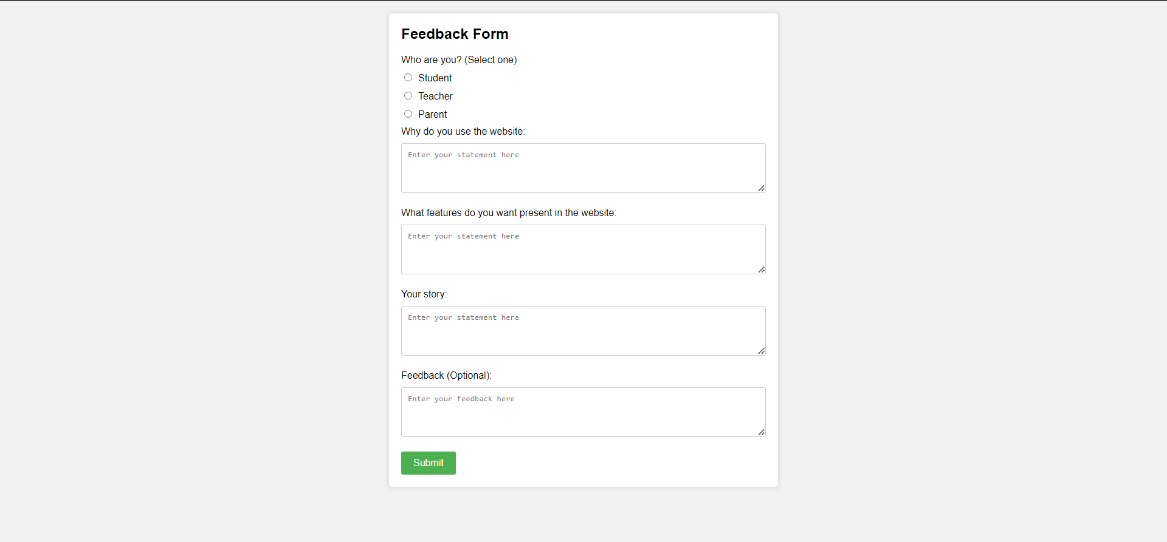

1. **UML Diagrams:**
2. **Use Case Diagram:**

This is the Use Case UML Diagram for our Smart Educational Website.

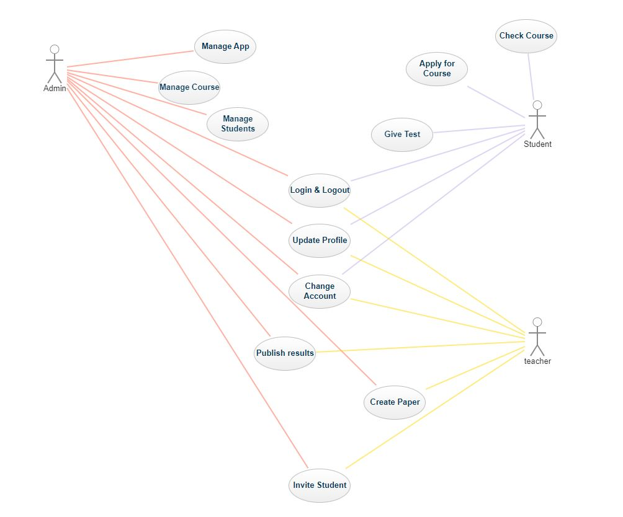

1. **Sequence Diagram:**

This is the Sequence Diagram for our Smart Educational Website.

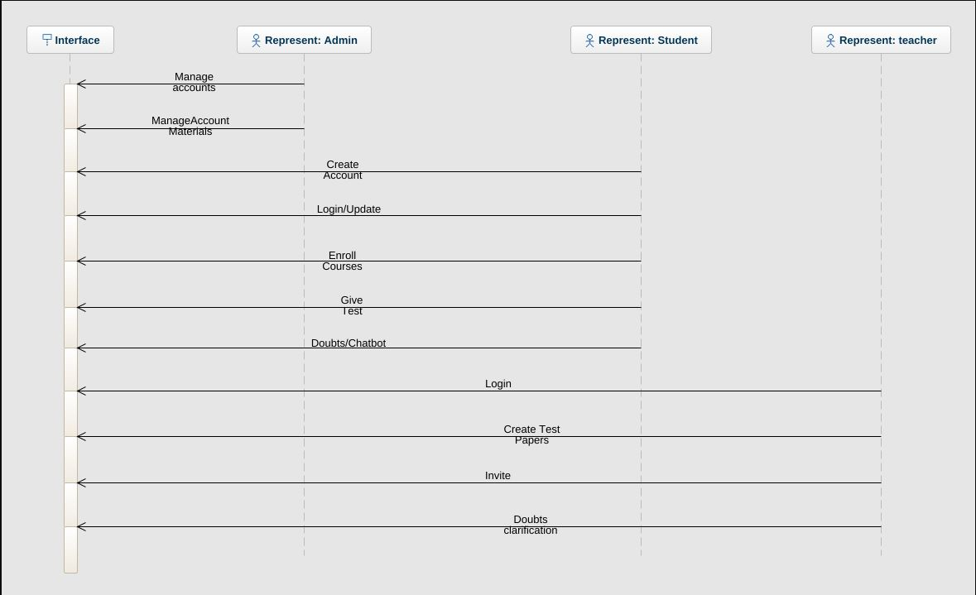

1. **Activity Diagram:**

We have provided two UML Activity Diagrams for our Smart Educational Website. The first diagram is our Login Activity Diagram which captures the process of the login of the client and admin to our Smart Educational Website.

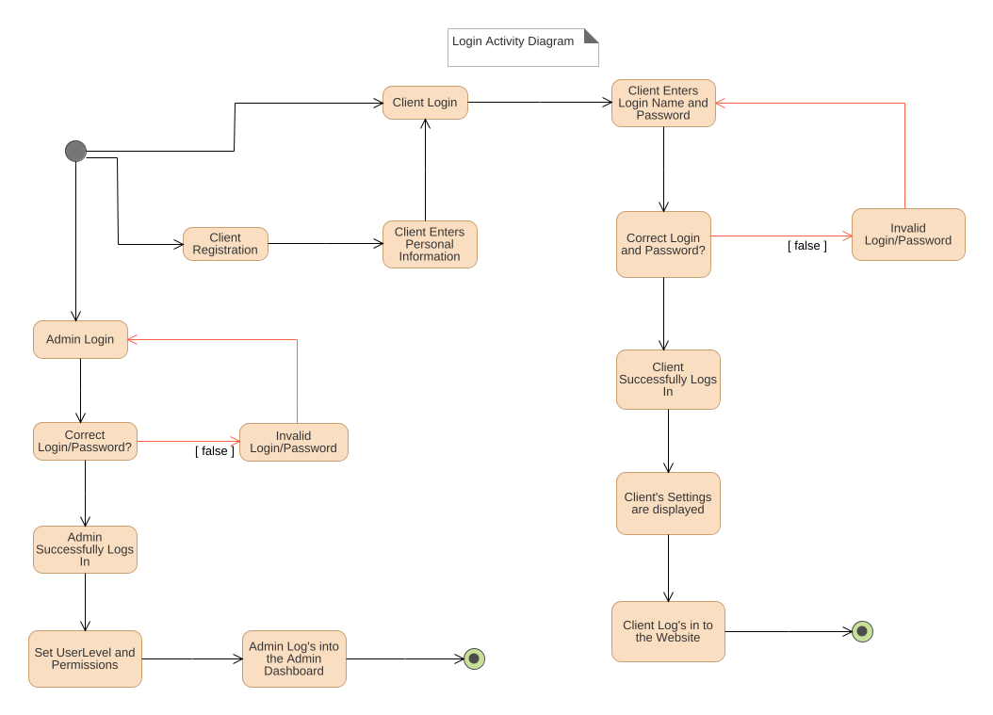

The second diagram is the Website Activity Diagram for our Smart Educational Website which captures the process on what the client performs on our Smart Educational Website.

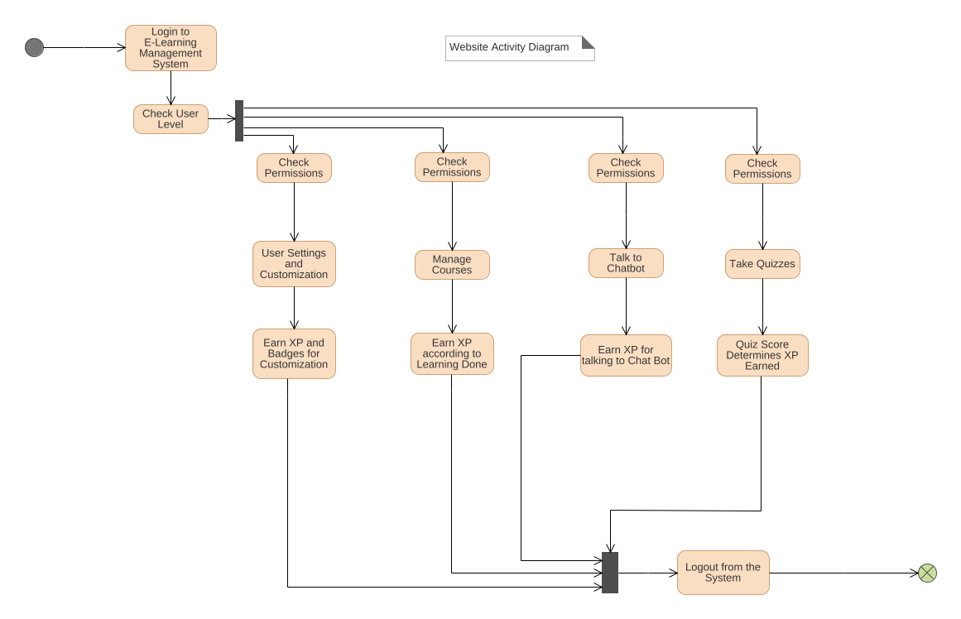

1. **Deployment Diagram:**

This is the UML Deployment Diagram for our Smart Educational Website.

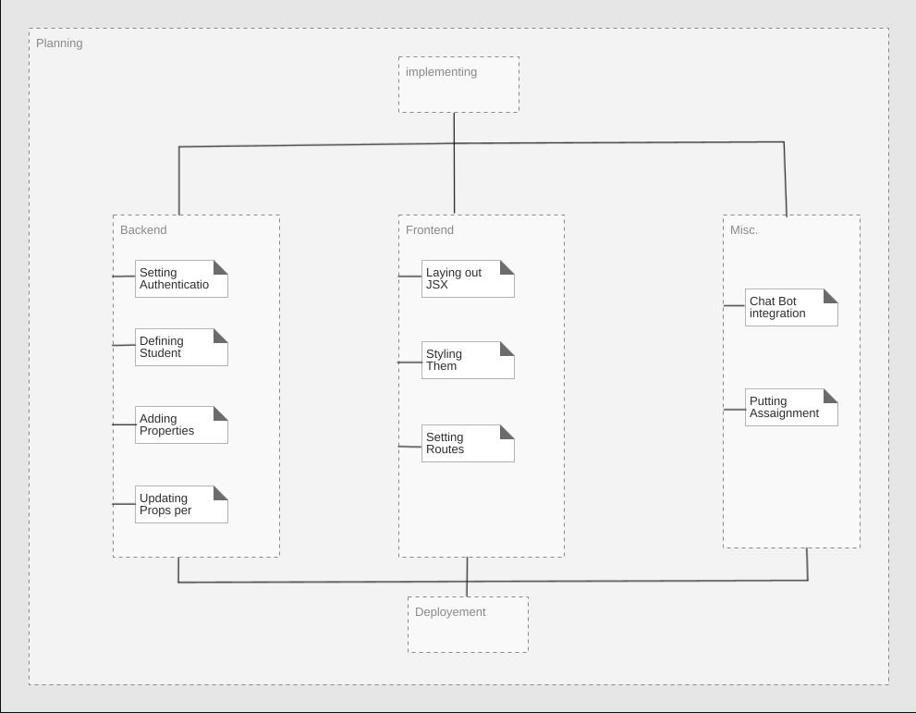

1. **Open Source Licensing Statement:**

We are using the MIT License as it gives express permission for users to reuse code for any purpose, sometimes even if code is part of proprietary software. As long as users include the original copy of the MIT license in their distribution, they can make changes or modifications to the code to suit their own needs. We have provided a copy along with a picture of our License below:

**MIT License**

**Copyright (c) Meta Platforms, Inc. and affiliates.**

**Permission is hereby granted, free of charge, to any person obtaining a copy**

**of this software and associated documentation files (the "Software"), to deal**

**in the Software without restriction, including without limitation the rights**

**to use, copy, modify, merge, publish, distribute, sublicense, and/or sell**

**copies of the Software, and to permit persons to whom the Software is**

**furnished to do so, subject to the following conditions:**

**The above copyright notice and this permission notice shall be included in all**

**copies or substantial portions of the Software.**

**THE SOFTWARE IS PROVIDED "AS IS", WITHOUT WARRANTY OF ANY KIND, EXPRESS OR**

**IMPLIED, INCLUDING BUT NOT LIMITED TO THE WARRANTIES OF MERCHANTABILITY,**

**FITNESS FOR A PARTICULAR PURPOSE AND NONINFRINGEMENT. IN NO EVENT SHALL THE**

**AUTHORS OR COPYRIGHT HOLDERS BE LIABLE FOR ANY CLAIM, DAMAGES OR OTHER**

**LIABILITY, WHETHER IN AN ACTION OF CONTRACT, TORT OR OTHERWISE, ARISING FROM,**

**OUT OF OR IN CONNECTION WITH THE SOFTWARE OR THE USE OR OTHER DEALINGS IN THE**

**SOFTWARE.**

